HOPE-SIM CLEM-Controller-V1.0.0

This version of the program has tested on Windows 10 operating system.

The program was written by LabVIEW 2019.

This program can control the whole system (lasers, SLM, stage and camera) of HOPE-SIM. HOPE-SIM View can be used to set up cryo-FM imaging parameters (e.g., the exposure time and focusing zone), map the area of the whole grid, register the list of targets of interest, change the laser channel and power intensity, control the stage movement, and collect multichannel WF/2D-SIM/3D-SIM raw data.

Before running this program, the hardware should be mounted well and the driver should be installed. And the corresponding LabVIEW subprogram of the hardware should be downloaded and installed.

The following is the interface of the program.

1. Main page

The main page of HOPE-SIM View that includes the Camera Control, EM-grid map importing panel, list of ROIs panel, z-focus panel and controlling panel.

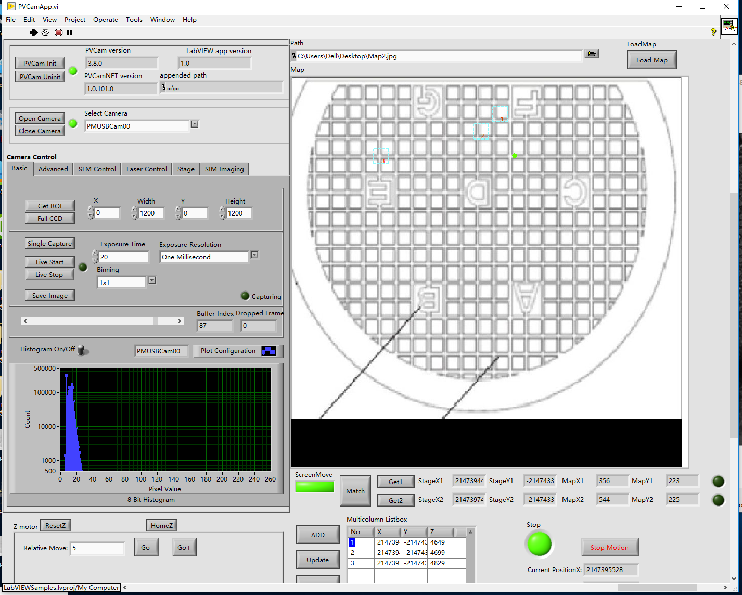

2. Map match

(1) The file address is for a map file map.jpg for loading EM-grid map into ‘LoadMap’ importing panel;

(2) Click and darken “ScreenMove” button at first, then click and lighten circular button at the starboard side of “Get1”, and move stage to marker 1 on grid (e.g., letter A), click corresponding location on map.jpg, and then click ‘’Get1’, to record the first reference coordinates for map alignment;

(3) Click and darken circular button at the starboard side of “Get1”, then click and lighten circular button at the starboard side of “Get2”, and move stage to marker 2 on grid (e.g., letter G), click corresponding location on map.jpg, and then click ‘’Get2’, to record the second reference coordinates for map alignment;

(4) Click “Match” to calculate the coordinate transformation between map.jpg and grid position;

(5) Click and lighten “ScreenMove” button, then click the position on the map to go.

(6) You can add, delete, or update the position of ROIs by click “ADD”, “DEL” or “Updata”.

3. Advanced camera setting

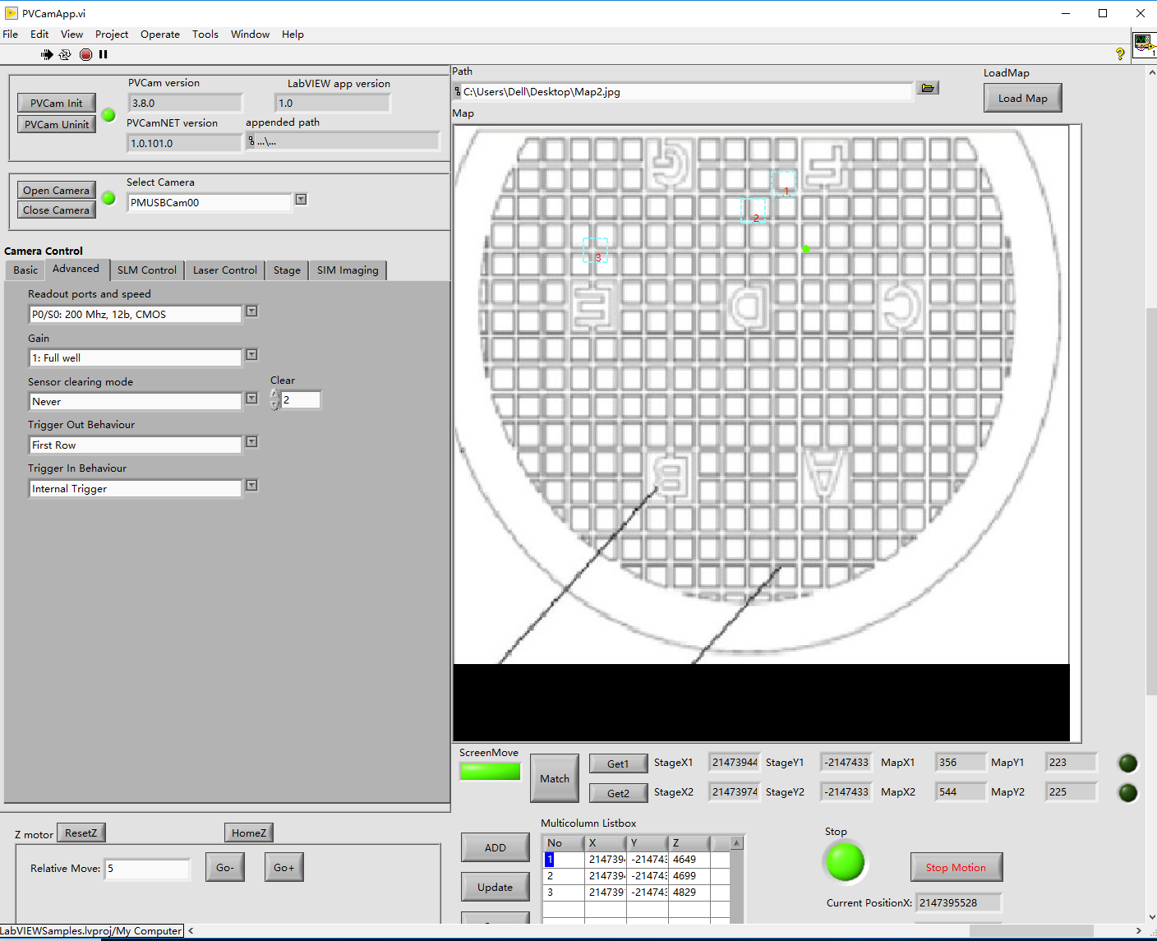

4. SLM control

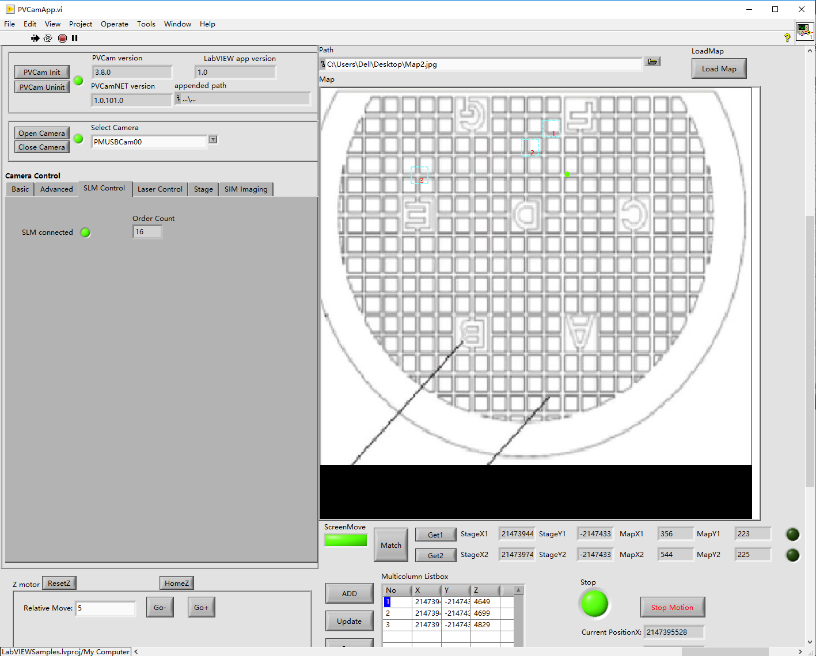

5. Lasers and AOTF control

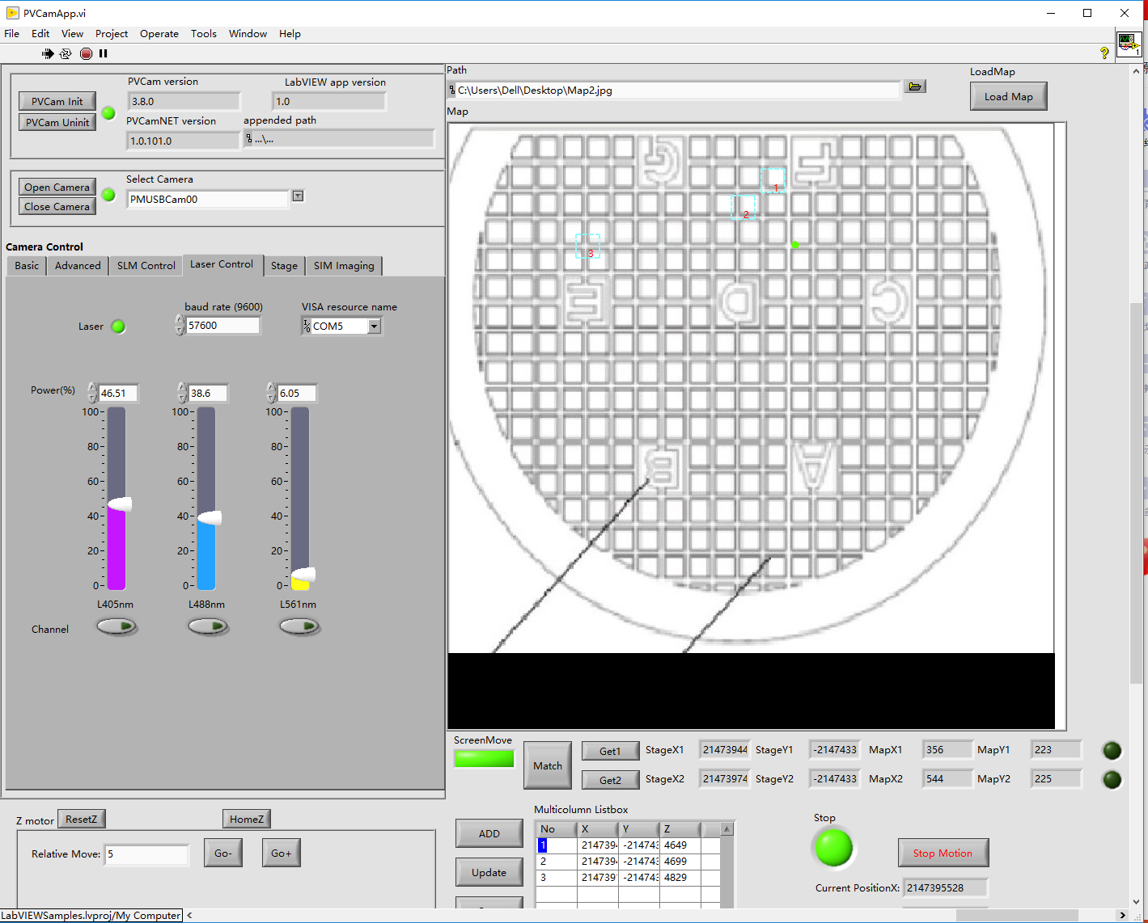

6. Stage XY move control

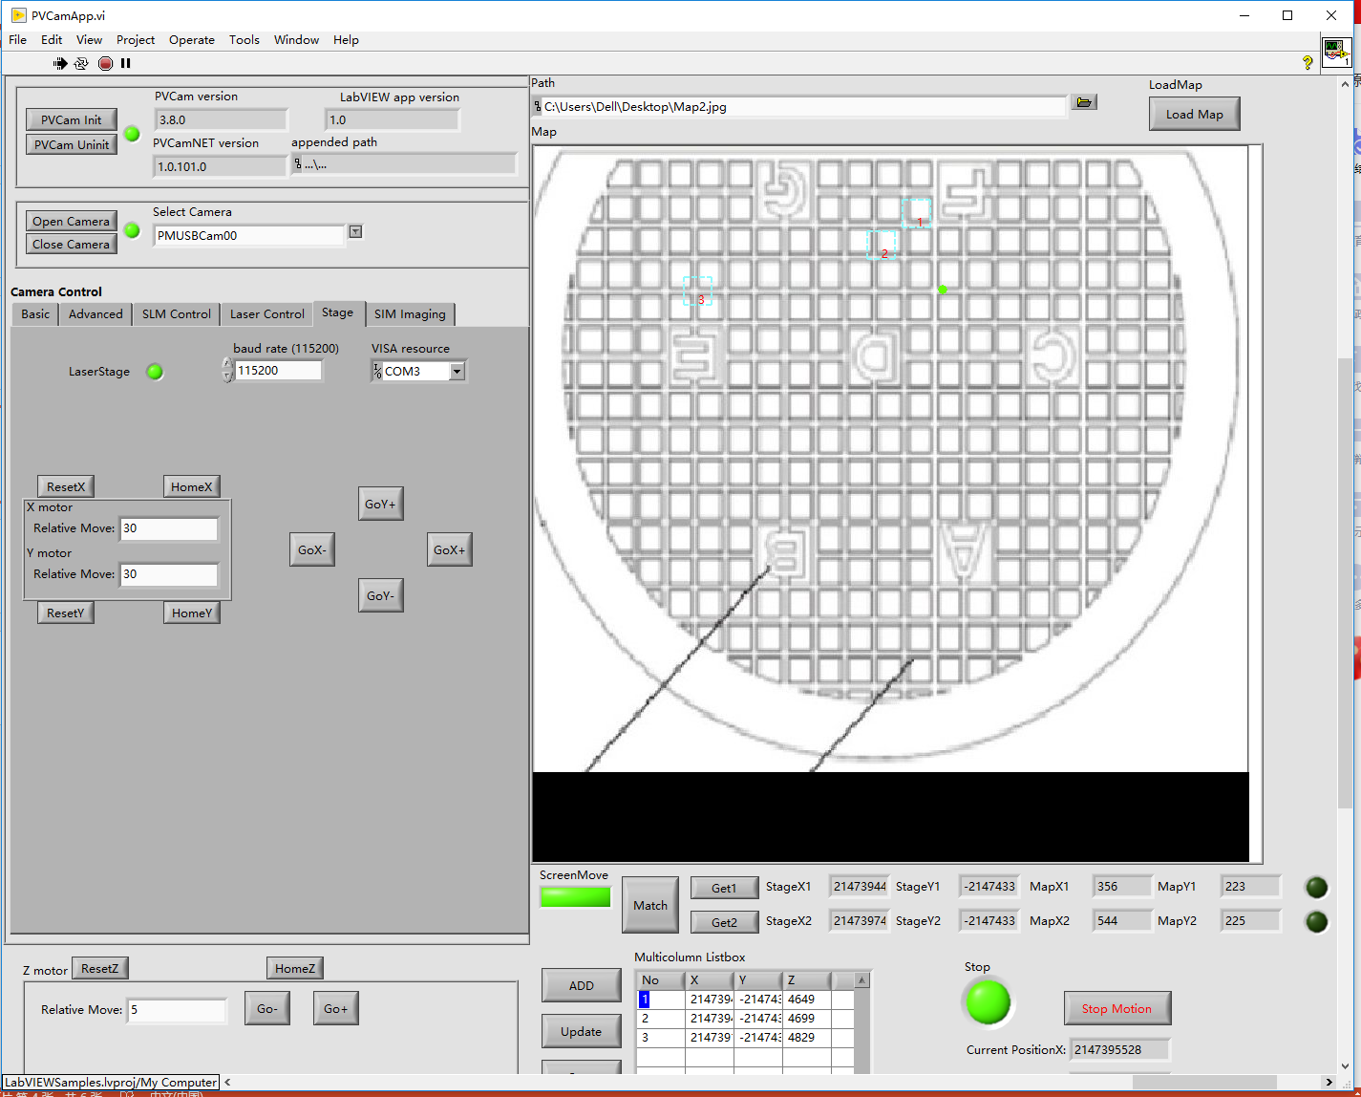

When the program runs, XY motors connect light become on station means the program has connected with the hardware.

Each motor can have “Reset”, “Home”, “Go-”, “Go+”. You can set the step and put the “Go-”, “Go+” buttons for step motion.

Put “Reset” button can set the current position to 0.

Put “Home” button can move the stage to the 0 position.

7. Z focusing



8. WF/2D-SIM/3D-SIM imaging

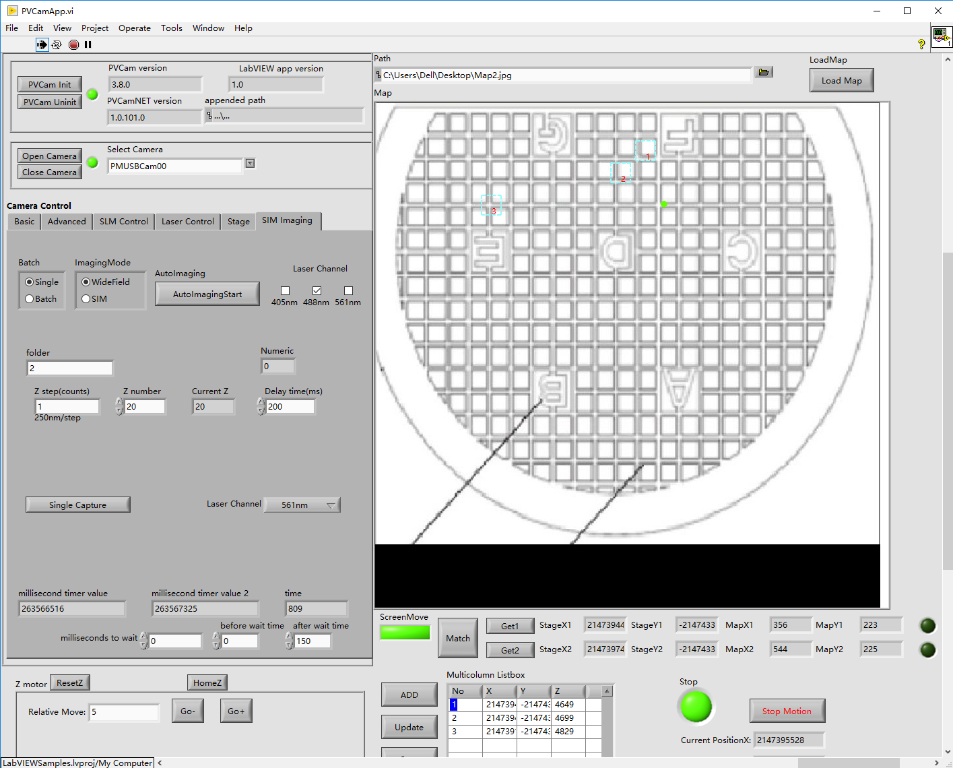

3D-SIM requires 15 images per z-plane, to satisfy Nyquist-Shannon sampling, raw data serials of cryo-SIM based on dry objective (NA0.9) are collected at 250 nm increments along the z axis as 1200 × 1200-pixels image with voxel size of 120 × 120 × 250 nm. The raw data was were collected in five phases for each of three angles. Each exposure depends on the overall fluorophore intensity, and the dataset is collected within an average time of 5-10 min capturing a field of view in all z slices (~20μm) required.